This document shows the steps I followed to complete the WordPress deployment example from Chapter 2 using AWS CloudFormation. The screenshots below provide proof of the stack creation, AWS resources, and successful access to the WordPress application. All resources were created using Free Tier–eligible services and were deleted after completing the assignment.
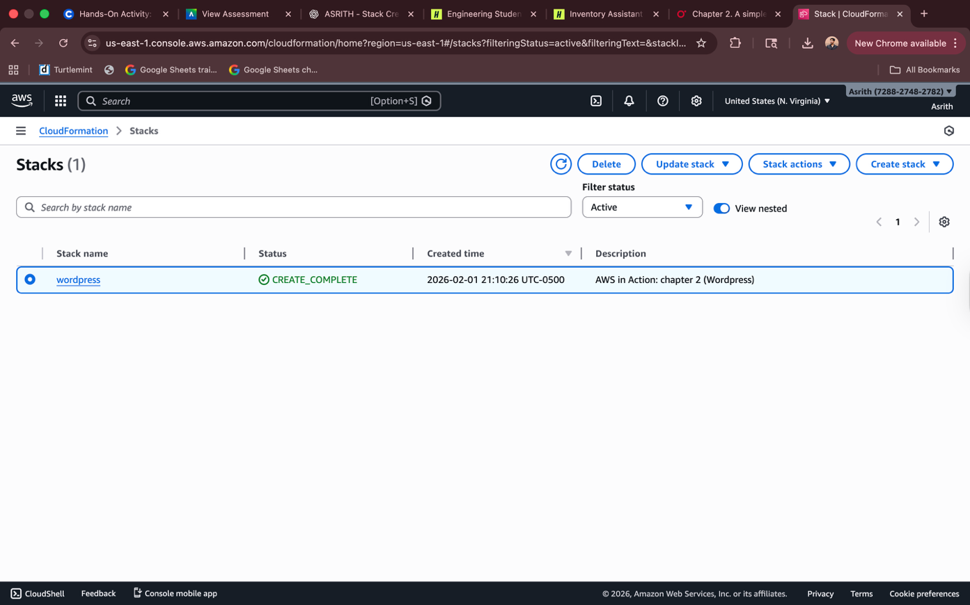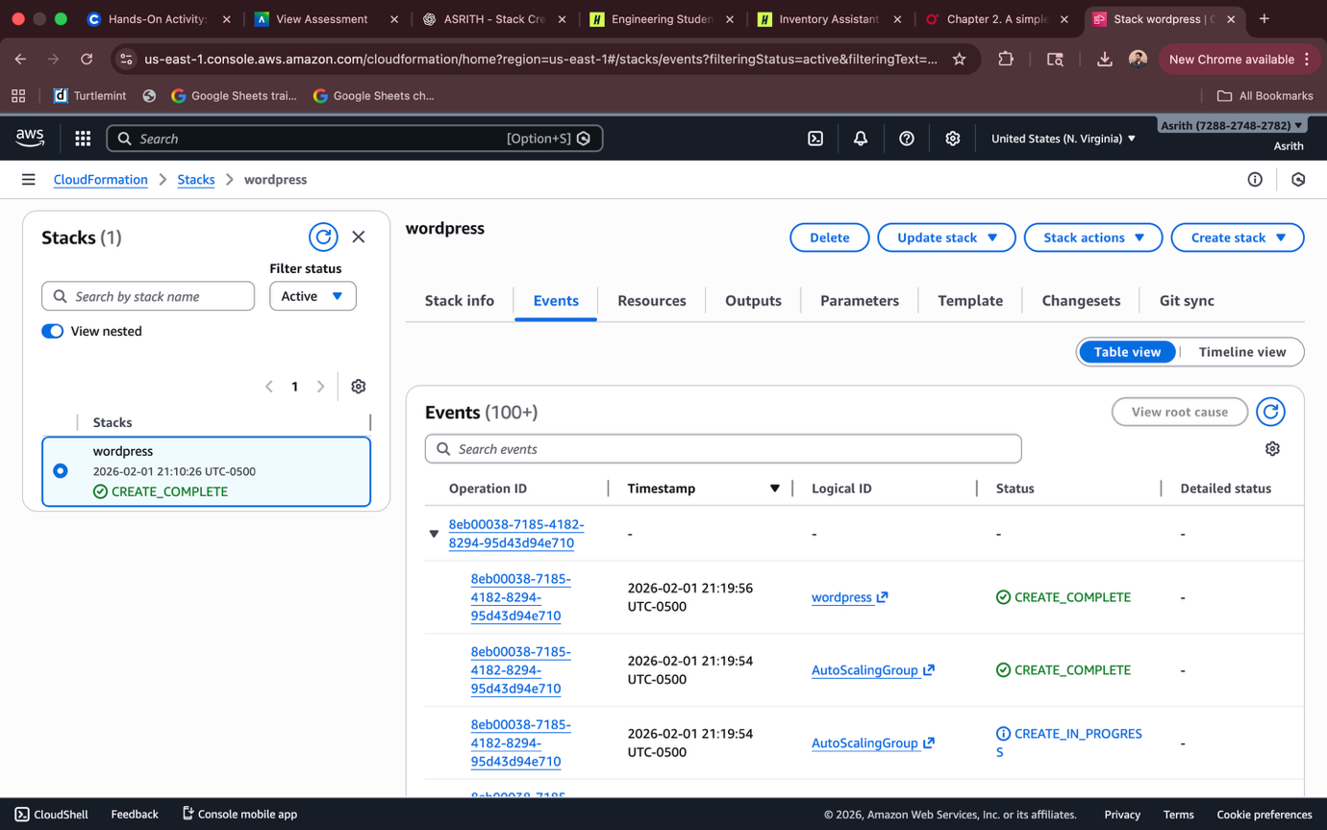
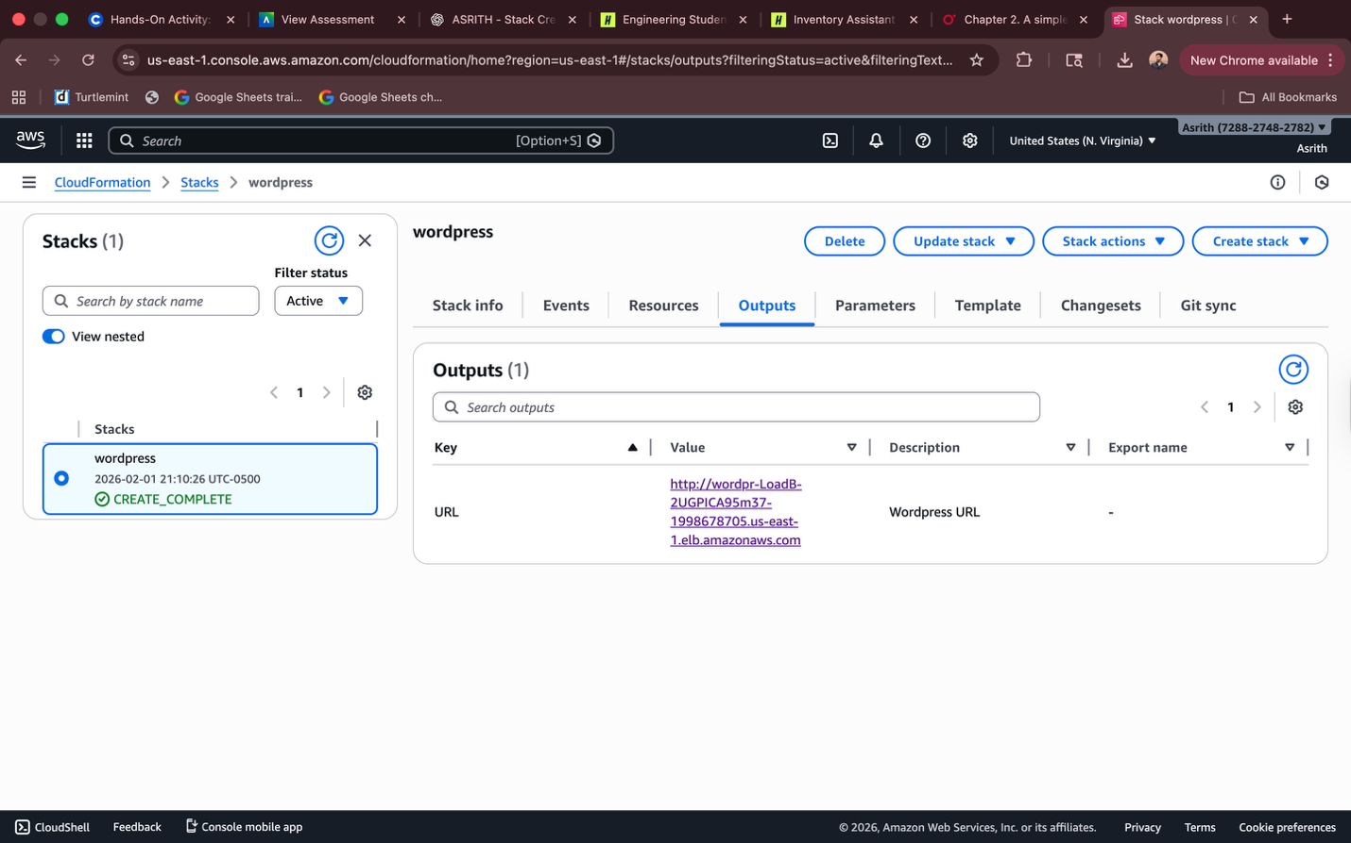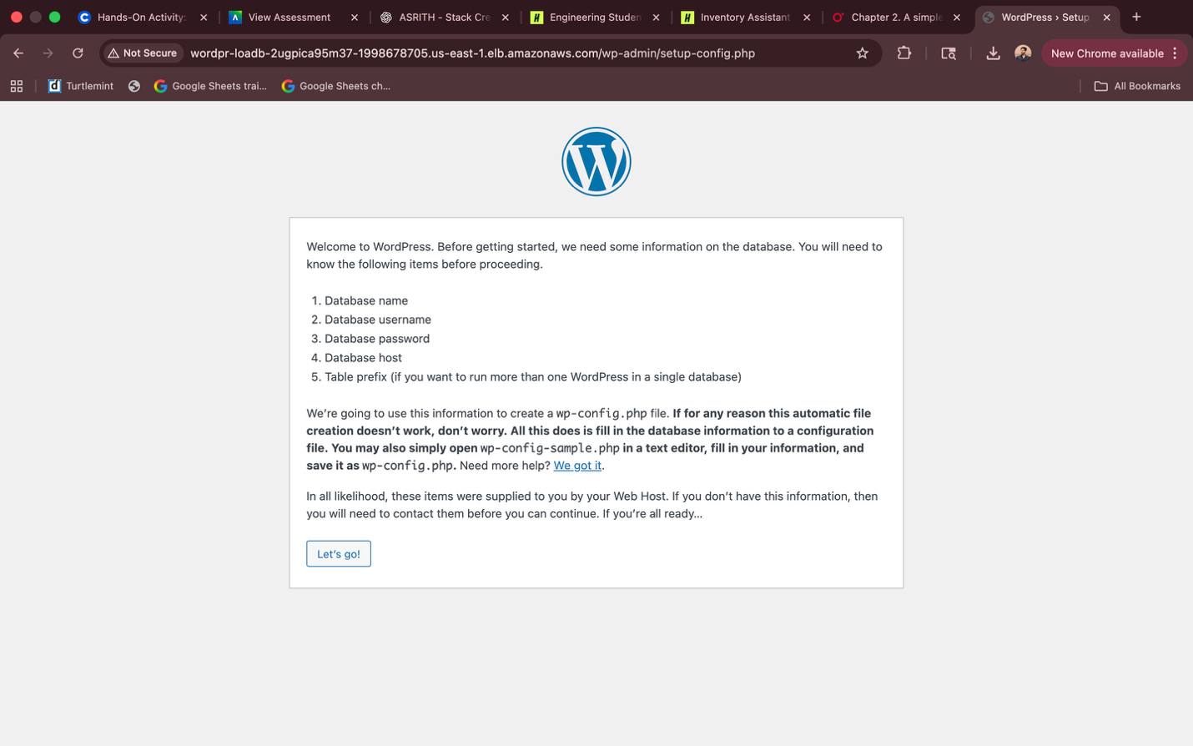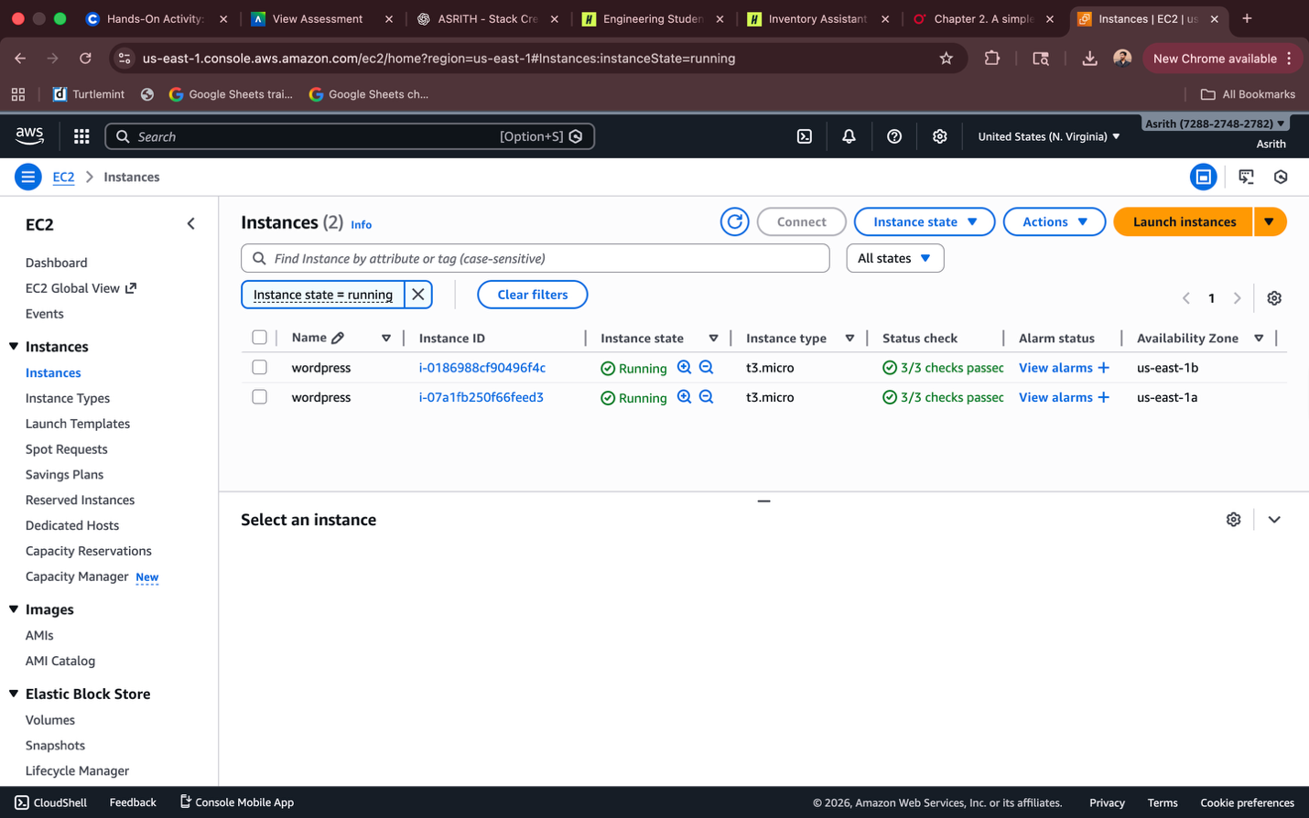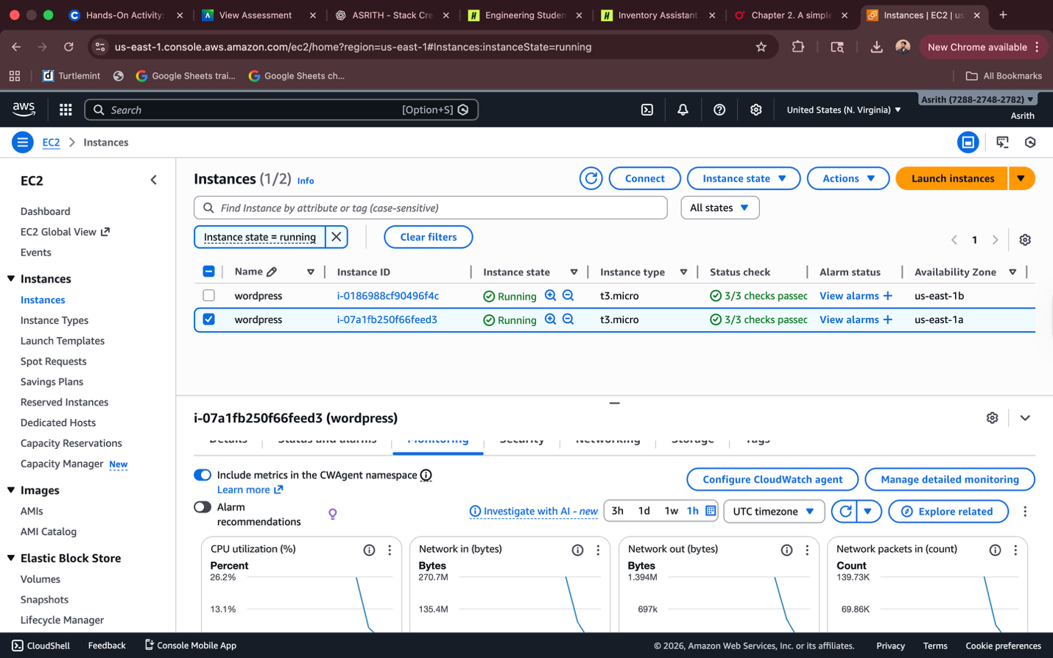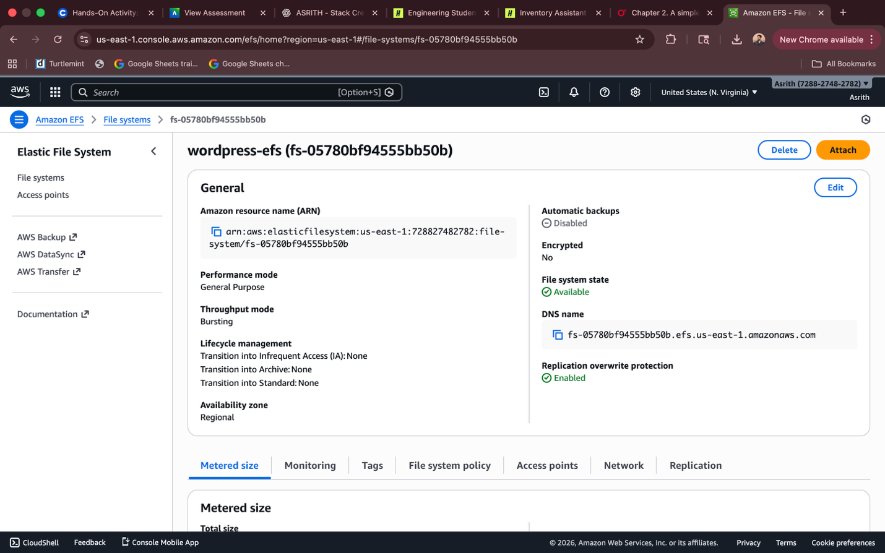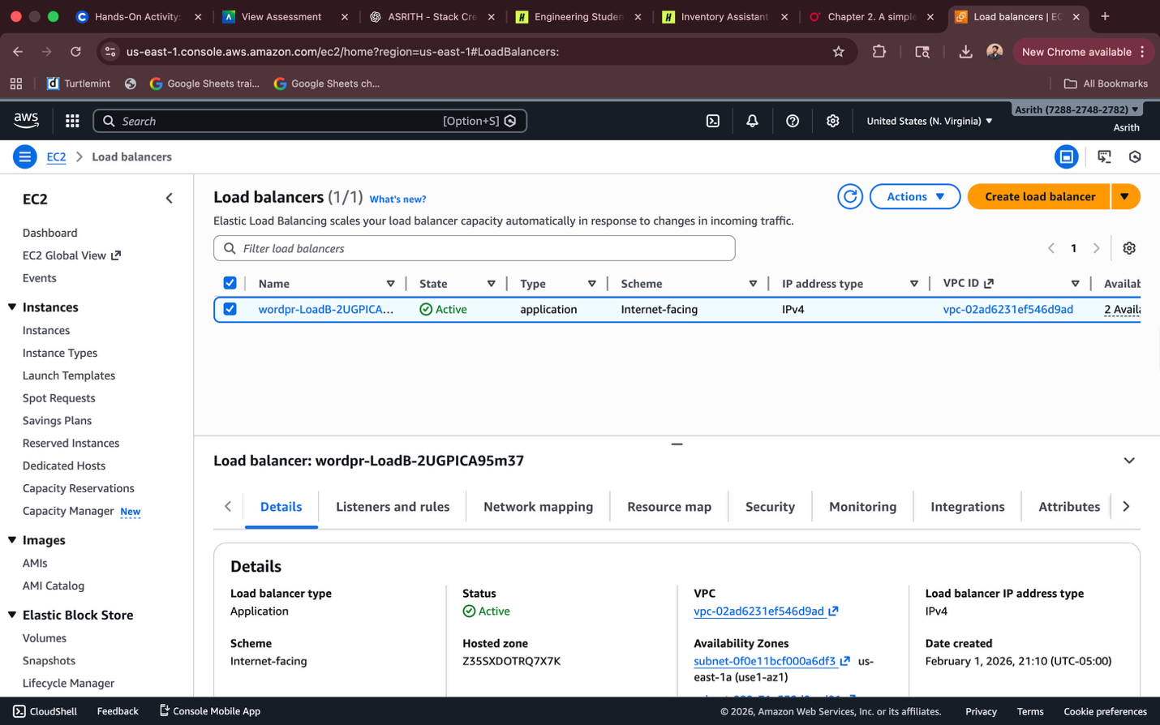
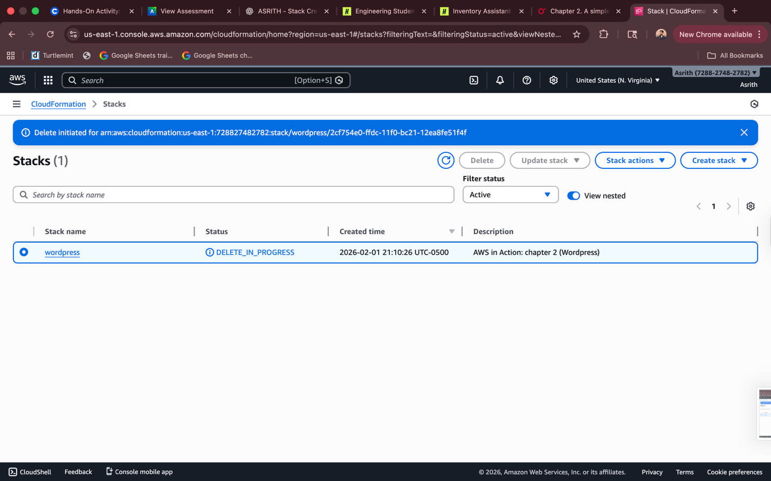

I was able to complete all the required steps of the WordPress example from Chapter 2 successfully. The CloudFormation stack deployed correctly, the necessary AWS resources were created, and the WordPress application was accessible as expected. After completing the assignment, all resources were deleted to avoid any charges.

